**ST. ELIZABETH GRILS’ SCHOOL**

**END OF TERM ONE ASSESSMENT 2024**

**INFORMATION AND COMMUNICATION TECHNOLOGY**

**CLASS:** SENIOR ONE **STREAM…………………. DURATION:** 1hr

**NAME: ………..…………………………………………………………………………..**

**ITEM**

Rhoda is setting up a home office and needs to assemble a complete computer system. She has the following hardware components a monitor, keyboard, mouse, printer, system unit, speaker among others. As an ICT student with knowledge about computer hardware and skills about setting up a computer system you have been contacted by Rhoda.

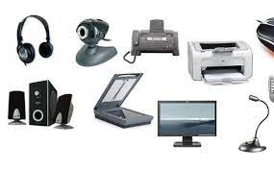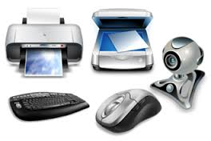

**TASK**

Guide her on the steps she should take to assemble and connect these peripherals to her system unit. Share with her any necessary information that may be required.

**Answer:**

1. Connect the monitor to the computer using the appropriate cable (HDMI, VGA, or DVI).
2. Connect the keyboard and mouse to the USB ports on the computer.
3. Connect the printer to the computer using a USB cable or set it up wirelessly if it supports Wi-Fi connectivity.
4. Install the printer drivers from the manufacturer’s website or use the installation CD if provided.
5. Connect the external hard drive to the computer using a USB cable.
6. Ensure that all connected peripherals are recognized by the computer. If any device is not recognized, check the device manager for driver updates or installation issues.
7. Configure printer settings (such as default printer) and external hard drive settings (such as backup schedules)